DATA STRUCTURES AND ALGORITHM
* LIST
* ARRAY
* LINK LIST
* DOUBLE LINK LIST
* STACK
* QUEUES
* TREES
* HASHMAPS
* GRAPHS
* RECURSION
* DYNAMIC PROGRAMMING

LIST :
- Store a given number of elements of a given data-type.
- Write/modify element of a position.
- Read elements at a position.
- Array is the data structure that gives the implimintation of the LIST.

FEATURES OF LIST/ARRAY:
Static arrays are allocated memory at compile time and the memory is allocated on the stack. Whereas, the dynamic arrays are allocated memory at the runtime and the memory is allocated from heap.
- empty list has size 0
- insert
- remove
- count
- read/modify elements at a position
- specify data-type
- List indexing starts with 0
- When a new integer is inserted into the list and if the index is not specified then the integer gets added to the end of the list or tail of the list.
- when you insert an element in the middle of the list, the index of all the further elements will change.
- When array is full, create a new larger array of double size and copy the previous array into the new array and free the memory for the previous array.
- Arrays in python - when ever we create a new insertion in the array after the array is full, a new array is formed which is double the size of the original array and then we have to copy all the inital values to that array and then add the new values.
- In python array you can store multiple types of element in an array.

BIG O FOR ARRAY:
- Access – O(1) {Since any element can be accessed easily in 1 step hence this is a good feture of the array where this can be better then the other data structures}
- Insert – O(n)
- Remove -- O(n)
- Adding – O(n)

DRAWBACKS OF AN ARRAY:
- Not good for dynamic memory allocation
- size is predefined and can’t be extended after formation.
- adding or removing an element is a lengthy process where the index of the elements keep changing continuously.
- Not a best utilization of the memory.

LINKED LIST DS:
- link list is a non-contiguous block of memory.
- insertion of an element in between the list is possible without changing the inde of the other elements.
- link list take 2 blocks to store the memory where in one block it stores the value of the element and in the other block it stores the address of the next element called the pointer variable.
- In C++ we store the link list element value as Struct Node{ int data; //4 bytes
Node* next; //4 bytes} ‘*’ represents the pointer to the node.
- first node is the head node.
- Address of the last node is 0.
- node can be created when ever we want
BIG O OF LINK LIST:
- Access – O(n)
- Insertion – O(n)
- delete – O(n)

LINK LIST VS ARRAY:

LINK LIST:  1.cost of accessing an element is more then array.  2. data is not stored in contiguous blocks of memories.O(n)  3. no wasteage of memory as the size can be changed later.  4. extra usage of memory for pointer variables.  5. takes a lot of space for stroing the data.  6. Inserting an element:  - at beginning – O(1)  - at the end – O(n)  - ith position - O(n) | ARRAY:  1. cost of accessing an element is less and easy.  2. data is stored in contiguous blocks of memories.O(1)  3. size is predefined and can’t be increased/decreased.  4. no space used for pointor variables.  5. nearly 1/4th of the memory to store the data.  6. Inserting the element:  - at beginning – O(n)  - at end O(1)  - ith position - O(n)

- array is easy to use compared to linked list.
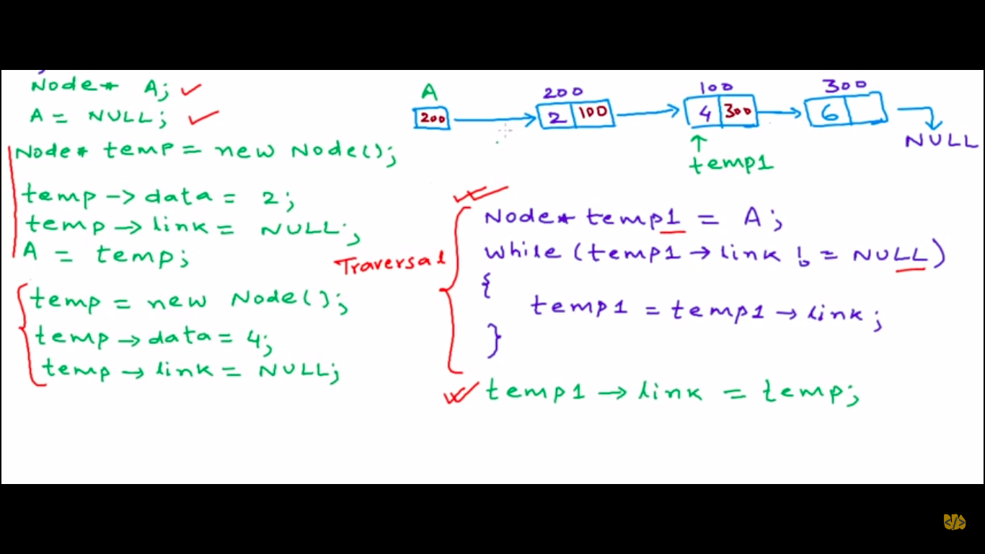

BIG O NOTATION:
-as the size of the input grows the processing time also grows.
- The notation in big o depends on the type of growth of a time taken for execution.{Mathematically speaking, the equation of the graph which shows the growth of the function will help you find out the big o’ of that function}
- rules for determining the big O’:
-keep the fastest growing term in the equation.
-drop constants.
- There are 2 types of big o notation:
-time growth aka time complexity
-space growth aka space complexity

Below represents the big o’ calculation for binary search:
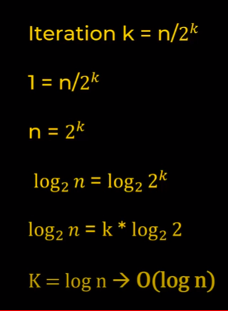

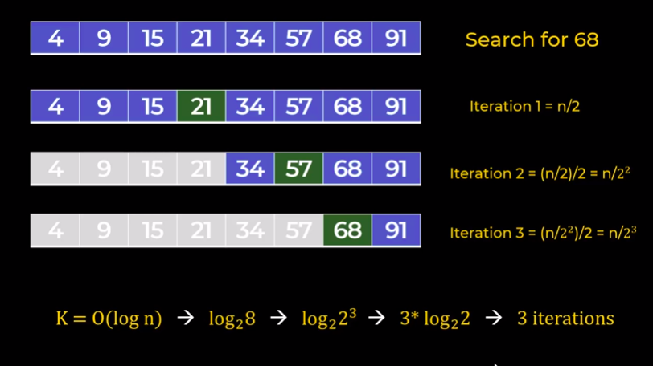

where:
K = number of iteration
n = number of elements in an array

- In binary search we search for an element by dividing the index number by 2 and the checking if the element is greater than or less then the number that we are looking for. {This is one of the approach for finding an element}

Big O Notation for Link List:
- insert element at beginning = O(1)
- Deleting an element at beginning = O(1)
- Insert or delete element at the end = O(n)
- Link list traversal = O(n)
- Accessing value = O(n)

advantages of LL:
1. You don’t have to pre-allocate the space in advance.
2. Insertion and deleting is easier.

Array and Link list comparison:
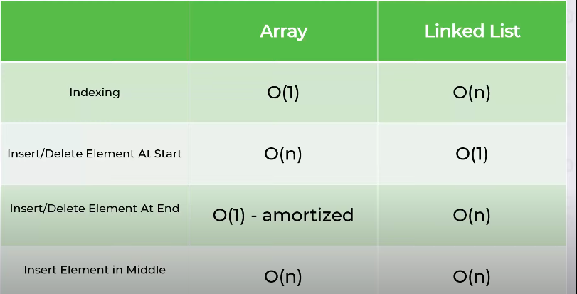

Code for implimintation of link list in python:

class Node:
def __init__(self, data=None, next=None):
self.data = data
self.next = next

class LinkedList:
def __init__(self):
self.head = None

def print(self):
if self.head is None:
print("Linked list is empty")
return
itr = self.head
llstr = ''
while itr:
llstr += str(itr.data)+' --> ' if itr.next else str(itr.data)
itr = itr.next
print(llstr)

def get_length(self):
count = 0
itr = self.head
while itr:
count+=1
itr = itr.next

return count

def insert_at_begining(self, data):
node = Node(data, self.head)
self.head = node

def insert_at_end(self, data):
if self.head is None:
self.head = Node(data, None)
return

itr = self.head

while itr.next:
itr = itr.next

itr.next = Node(data, None)

def insert_at(self, index, data):
if index<0 or index>self.get_length():
raise Exception("Invalid Index")

if index==0:
self.insert_at_begining(data)
return

count = 0
itr = self.head
while itr:
if count == index - 1:
node = Node(data, itr.next)
itr.next = node
break

itr = itr.next
count += 1

def remove_at(self, index):
if index<0 or index>=self.get_length():
raise Exception("Invalid Index")

if index==0:
self.head = self.head.next
return

count = 0
itr = self.head
while itr:
if count == index - 1:
itr.next = itr.next.next
break

itr = itr.next
count+=1

def insert_values(self, data_list):
self.head = None
for data in data_list:
self.insert_at_end(data)

if __name__ == '__main__':
ll = LinkedList()
ll.insert_values(["banana","mango","grapes","orange"])
ll.insert_at(1,"blueberry")
ll.remove_at(2)
ll.print()

ll.insert_values([45,7,12,567,99])
ll.insert_at_end(67)
ll.print()

